TOPIC TWO
FIX SOLAR SYSTEM COMPONENTS
METHODS OF SOLAR PANEL CONNECTION
There are different methods of connecting solar panels. They include:
- Series Connection
- In series connection, the positive terminal of one solar panel is connected to the negative terminal of the next panel, and so on.
- The voltage adds up while the current remains the same across all panels.
- Used when you need to increase the voltage of the system while keeping the current constant.
- If one panel in the series is shaded or malfunctioning, it can affect the performance of the entire string.
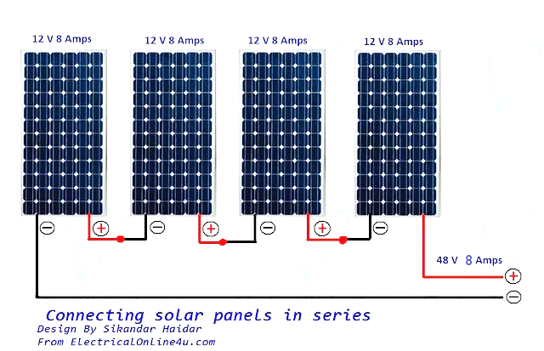
- Parallel Connection:
- In parallel connection, all the positive terminals of the panels are connected together and all the negative terminals are connected together.
- The current adds up while the voltage remains the same across all panels.
- Used when you need to increase the current of the system while keeping the voltage constant.
- If one panel in the parallel connection is shaded or malfunctioning, it does not significantly affect the performance of the other panels.
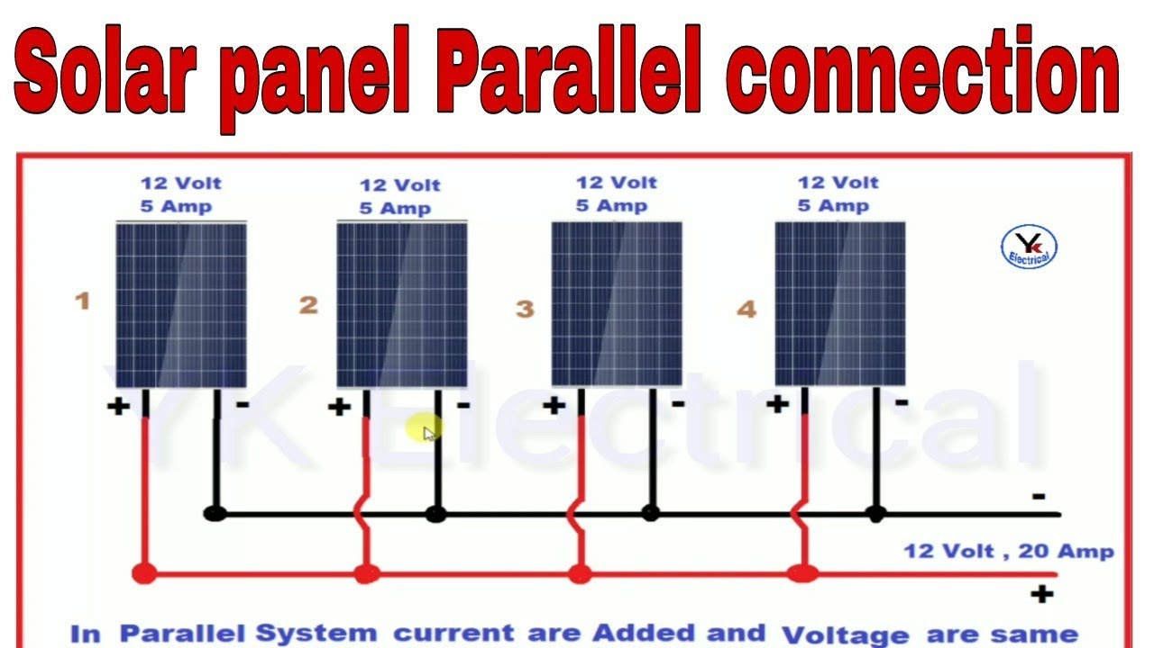
- Series-Parallel Connection (Combination):
- This method combines both series and parallel connections.
- Panels are grouped in series, and then these series groups are connected in parallel.
- Provides a balance between increased voltage and current.
- Offers some redundancy against shading or malfunctioning panels, as the impact is limited to the affected series group.

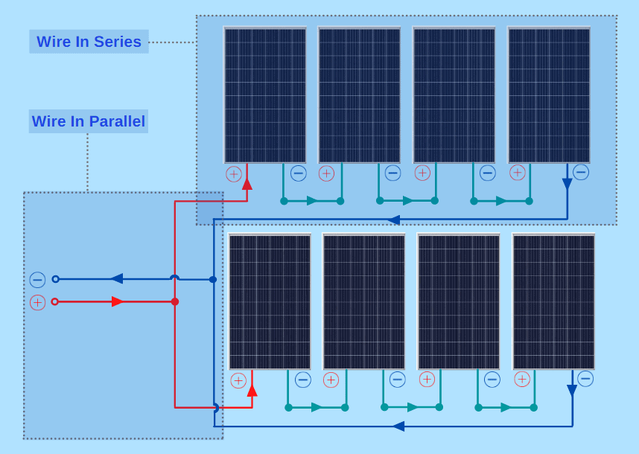
SOLAR PANEL COMPONENTS
Charge controller
A charge controller is a crucial component in a solar power system, especially for systems with battery storage. Its main function is to regulate the voltage and current coming from the solar panels going to the battery and prevent overcharging. Key aspects:
- Voltage Regulation: Charge controllers monitor the voltage of the battery bank and the solar array. When the battery voltage rises to a certain level (typically around 14.4 volts for a 12-volt system), the charge controller will reduce or stop the flow of current from the solar panels to prevent overcharging.
- Current Regulation: Charge controllers also regulate the current flowing into the batteries. They ensure that the charging current is appropriate for the battery's capacity and condition, preventing damage from overcurrent.
- Battery Protection: Charge controllers protect batteries from overcharging, which can lead to reduced battery life and safety hazards like overheating and outgassing of electrolytes. They also prevent deep discharge, which can damage batteries, by disconnecting loads when the battery voltage drops below a certain level.
- Load Control: Some charge controllers have built-in load control features, allowing them to manage DC loads connected to the system. They can automatically disconnect non-critical loads when the battery voltage is low to prevent deep discharge.
- Monitoring and Data Logging: Many modern charge controllers come with monitoring capabilities, allowing users to track system performance, battery status, and energy production. Some controllers also offer data logging features for long-term performance analysis and troubleshooting.
Types of charge controllers
- PWM (Pulse Width Modulation): PWM controllers rapidly switch the solar panel's current on and off, effectively controlling the charging by adjusting the width of the pulses. They are simpler and cheaper but less efficient compared to MPPT controllers.
- MPPT (Maximum Power Point Tracking): MPPT controllers use advanced algorithms to constantly track the maximum power point of the solar array and adjust the voltage and current to maximize power transfer. They are more efficient, especially in situations where the solar panel's voltage is higher than the battery voltage.
- One-Stage Charge Controller:
- One-stage charge controllers are the most basic type, often referred to as simple "on/off" controllers.
- They regulate the charging process by simply turning the charging current on when the solar panel voltage exceeds a certain threshold and turning it off when the voltage drops below a set point.
- Typically used in small solar systems where precise charging control is not critical, such as small off-grid applications like garden lights or small battery chargers.
- They are cost-effective and easy to install but lack the advanced features and efficiency of more sophisticated controllers like PWM or MPPT.
- Two-Stage Charge Controller:
- Two-stage charge controllers offer a slightly more advanced charging algorithm compared to one-stage controllers.
- They typically have two distinct charging stages: bulk and float.
- During the bulk stage, the charge controller delivers a higher charging current to the battery to quickly bring it up to around 80% to 90% of its capacity.
- Once the battery reaches this level, the charge controller switches to the float stage, where it maintains a lower charging voltage to keep the battery fully charged without overcharging.
- Two-stage controllers are commonly used in small to medium-sized solar systems where moderate charging control is needed, such as in RVs, boats, or small off-grid cabins.
- They offer better battery charging management compared to one-stage controllers and help extend battery life by preventing overcharging.
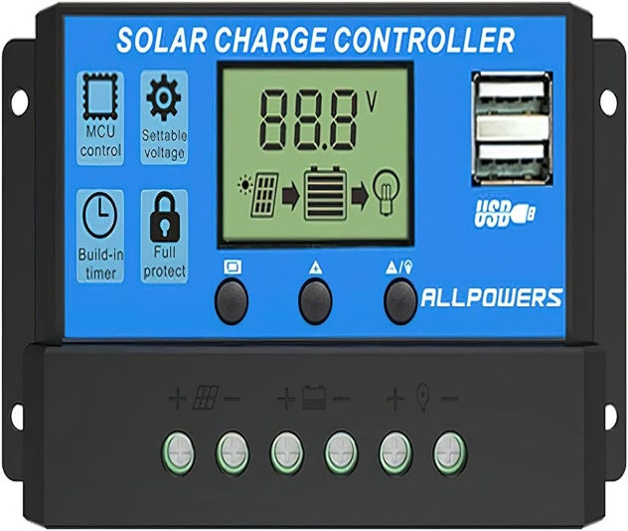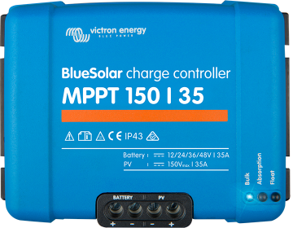
Inverters
Solar inverters play a crucial role in converting the DC (direct current) electricity generated by solar panels into AC (alternating current) electricity that can be used to power homes, businesses, and the grid.
- Function: Solar inverters convert the DC electricity produced by solar panels into AC electricity, which is the standard form of electricity used in homes and businesses. This conversion is necessary because most household appliances and the grid operate on AC power.
- Types:
  - String Inverters: These are the most common type of inverters used in residential and commercial solar installations. They are installed in a centralized location and connect multiple solar panels (usually in strings) to a single inverter. String inverters are cost-effective and reliable but may suffer from reduced performance if one panel in the string is shaded or malfunctions.
  - Micro inverters: Micro inverters are installed directly on each solar panel, converting DC electricity to AC at the panel level. They offer advantages such as individual panel optimization, improved performance in shaded conditions, and easier system monitoring. However, they are generally more expensive than string inverters.
  - Power Optimizers: Power optimizers are similar to micro inverters in that they are installed at the panel level. However, instead of converting DC to AC, they perform DC-to-DC conversion and optimize the power output of each panel before sending it to a central inverter. This configuration combines some of the advantages of micro inverters with the cost-effectiveness of string inverters.
- Efficiency: Solar inverters have efficiency ratings that indicate how effectively they convert DC power into usable AC power. Higher efficiency inverters can maximize the energy yield of a solar system by minimizing losses during the conversion process.
- Grid-Tie and Off-Grid Systems: Solar inverters can be designed for grid-tie systems, where excess electricity generated by the solar panels can be fed back into the grid, or for off-grid systems, where the solar panels are the sole source of electricity and batteries are used to store excess energy for use when the sun is not shining.
- Monitoring and Control: Many modern solar inverters come with built-in monitoring and control capabilities, allowing users to track the performance of their solar system, monitor energy production in real-time, and diagnose any issues remotely.
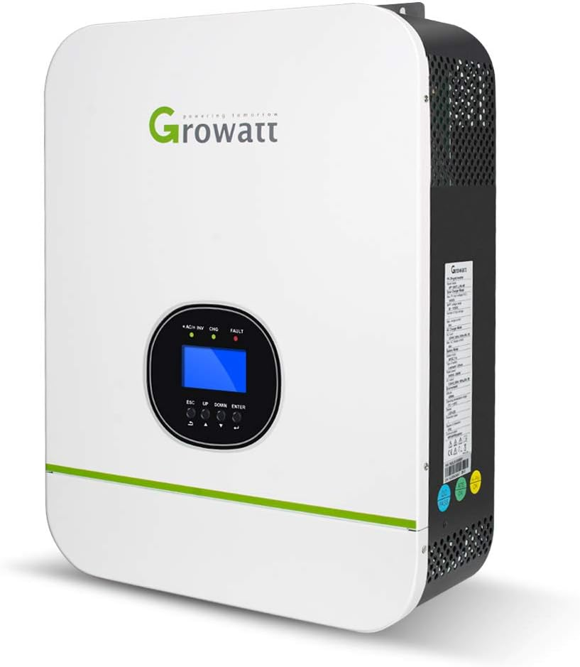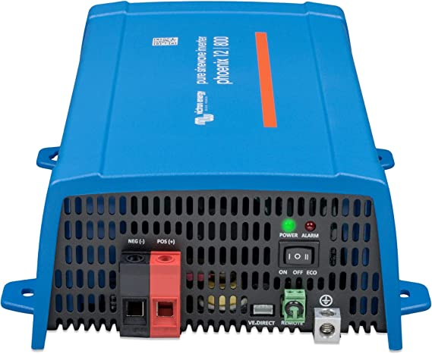

Cables
Cables are vital components in solar power systems, responsible for transmitting electrical energy between various components such as solar panels, inverters, charge controllers, batteries, and loads.
- Types of Cables:
  - DC Cables: Direct current (DC) cables are used to connect solar panels to charge controllers, inverters, or other DC loads. These cables need to be able to handle the high DC voltages generated by solar panels. Typically, they are made of copper to ensure low resistance and are insulated to protect against weather and environmental conditions.
  - AC Cables: Alternating current (AC) cables are used to connect inverters to the electrical distribution system of a building or to the grid. These cables carry the converted AC electricity from the solar system to power electrical appliances and devices. AC cables are also made of copper and insulated to meet safety standards.
- Sizes and Gauges:
  - The size or gauge of a cable refers to its diameter and determines its current-carrying capacity. Larger gauge cables have a greater current-carrying capacity and are used for higher power applications.
  - The appropriate cable size depends on factors such as the maximum current expected, the length of the cable run, and the voltage drop allowed. Undersized cables can lead to power losses and overheating.
  - Standard cable sizes are specified by organizations such as the National Electrical Code (NEC) in the United States or the International Electrotechnical Commission (IEC) internationally.
- Connectors:
  - Connectors are used to join cables together or to connect cables to solar panels, inverters, charge controllers, or other components.
  - Common types of connectors used in solar installations include MC4 connectors for DC connections between solar panels and TNC connectors for AC connections.
  - Proper installation and sealing of connectors are essential to prevent moisture ingress and ensure a reliable electrical connection.
- Installation Considerations:
  - Cables in a solar system should be routed and installed carefully to minimize voltage drop, maximize efficiency, and ensure safety.
  - They should be protected from physical damage, UV exposure, moisture, and extreme temperatures.
  - Cable runs should be properly secured and supported to prevent sagging or damage over time.
Solar system connections for a home
